In this post, I would like to explain my understanding of how neural networks work and why they are so powerful in representing any real world continuous function.

We all know about the basic linear function. i.e.

$y=wx+b$ Equation that represents a straight line.

Here,

w = slope of the line

b = bias of the line

In neural networks this concept is used, but instead of w and b being single numbers they are matrices or vectors.

Below is a demonstration of this with a simple example.

For instance, let us consider a simple example of classifying a mango to be unripe or ripe.

It is a binary classification, so the output y will be either 0 (unripe) or 1 (ripe).

The inputs or independent variables, x might be:

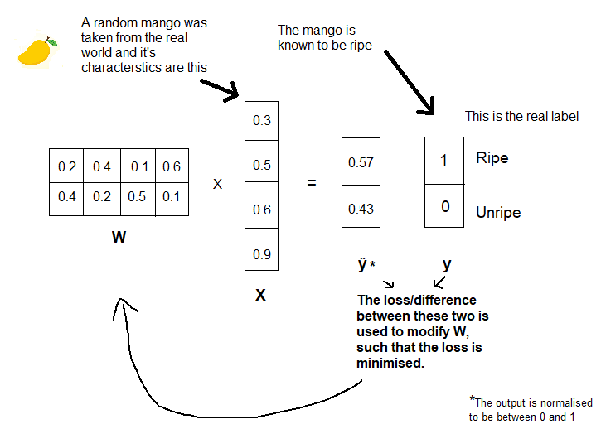Shape, Size, Color, Origin.

Let us take a Matrix of arbitrary values, W.

This is a simple intuition of how a one layer neural network would work.

How the loss is calculated. And how the

W matrix is updated need a lower level of abstraction to be explained. The above example can also be represented by the following diagram of neurons.

The hidden layer does not only do a dot product of the matrix W and x. It also applies an activation function on it.

